**Humanity Dashboard**

**Doc:** Humanity United Geospatial Dashboard Technic Report.

**Samples:** Some samples that I downloaded to learn.

**Data**

* ACLED_All_Africa_1997-2013: shapefile of ACLEC conflict events
* Geojson: geojson files for ACLED, poverty, and SCAD (These json files need to be checked, I am using these files as test files for the code)
* MBTile: These are mbtiles output from TillMill (I uploaded those mbtiles to my MapBox account, and it gave me Map ID for each mbtile)
* Poverty: Downloaded from Harvest Choice
* QGIS: The heat map was produced by QGIS, and then used TillMill to export mbtiles
* SCAD_1990-2011: SCAD conflicts data

**Myleaflet**

* **Interactive.html:** Can interactive with acled points
* **Overlay.html:** Can turn on/off of three overlay images (Upper Right) (In this web map, it has three layers from bottom to top: global baselayer (Can be changed to Albert’s blue marble), poverty (Harvest Choice poverty data), Africa conflicts (acled, each points represent a conflict). The poverty map legend, I coded legend in TileMill (Figure 1&2)
* These two should be merged together, but I haven’t have time to work on it.

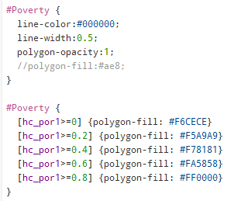 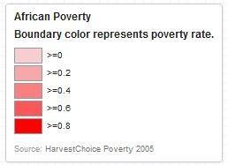

Figure 1. Poverty Legend Figure 2. Poverty Legend (Using “hc_por1” field)